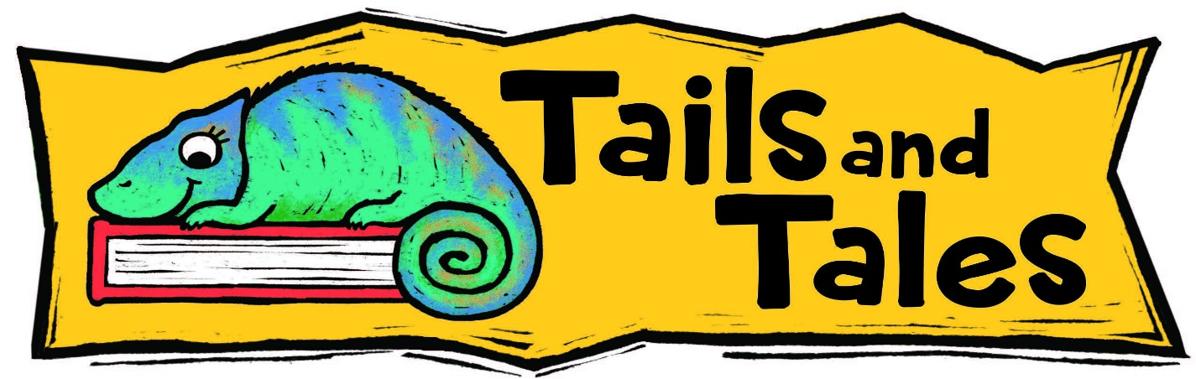
Summer Reading Log
Child’s Name _____________________________________ age ____ phone: _______________
Parent/Guardian Name _____________________________________ email: _______________
Rosemary Garfoot Public Library Summer Reading Program 2021: June 14 – Aug. 6
My Goal: _____________ books each week OR ___________ minutes each week

Week #1: June 14 – 20 Goal completed (Your story has begun!) ________________________________ (Guardian’s signature)
Week #2: June 21 – 27 Goal completed (You are an adventurer!) _______________________________

Week #3: June 28 – July 4 Goal completed (Awesome!) _______________________________________

Week #4: July 5 – 11 Goal completed (Hooray!) _____________________________________________
Pick up your halfway prize!! Call the library to set up a time. _________ staff initials
Week #5: July 12 – 18 Goal completed (Look at you go!) ______________________________________
Week #6: July 19 – 25 Goal completed (Wow!) _____________________________________________
Week #7: July 26 – Aug. 1 Goal completed (Fantastic!) ______________________________

Week #8: Aug. 2 – Aug. 6 Goal completed (You are a superhero!) ______________________________
Well Done! You earned a book!! _______ staff initials

Call or email Catherine at the library for instructions on how to order your prize book! 608-798-3881 or email: cabaer@rgpl.org

Even MORE fun right at home!

Here are some activities to do at home! For each one you complete you can earn a virtual badge on the Beanstack program or app. Send us a picture of your finished product for our online gallery, too! If you are not using Beanstack, come and get a sticker or bookmark at the library after you send in your photo.
- Attend at least 3 library programs and win a magic wand!
- Dress up like your favorite book character.
- Create a cover for an animal legend or trickster tale you imagine and bring it to the library to be displayed in our library window gallery.
- Create a reading nook somewhere in your house or yard.
- Read a story to your pet, or write to a Puppy Pen Pal! (see website or ask us how to sign up)

