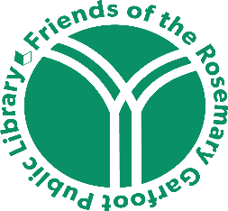 | Friends of the Rosemary Garfoot Public Library  Annual Meeting  Wednesday, October 18, 2023  6:30 PM  Rosemary Garfoot Public Library Community Room  AGENDA

- Welcome and Introductions

- Annual Update – Elizabeth Fayram, President

- Financial Report – Nicole Schaefer, Treasurer

- 2023 Fundraisers
  - Book Sale
  - Art Auction: November 13 – December 2
Help needed with set-up (November 10-11), take down, & communication with bidders

- Children’s Garden

- Little Libraries

- Library Update – Kelly McKewin

- Elections: Vice President and Treasurer (2-year terms)
Nominations being sought for Secretary

- Plans for 2024

