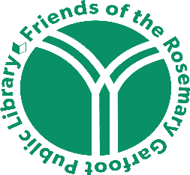 | Friends of the Rosemary Garfoot Public Library  Executive Board Meeting  Thursday, July 21, 2022  5:00 PM  Library Community Room  AGENDA

- September Book Sale – Cancellation

- Art Auction Planning – Denise Baylis

- Approval of Minutes – March 31, 2022

- Treasurer’s Report – Nicole Schaefer

- Library Update – Kris Loman

- Membership Update

- Other Activities

- Additional Business

- Annual Meeting – October, 2022

