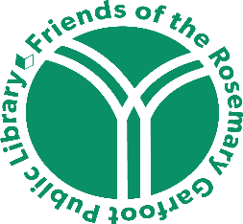 | Friends of the Rosemary Garfoot Public Library  Executive Board Meeting  Thursday, March 31, 2022  5:00 PM  Liz’s House  3095 Creekside Way  AGENDA
- Book Sale – Martha Brunner
  - Schedule
  - Solicitation of Help – Sorting and Sale
  - Donation Updates
  - Publicity
  - Book Sale Guidelines (attached to email)

- Approval of January 17, 2022 Minutes – Connie Kane

- Treasurer’s Report – Nicole Schaefer

- Library Update – Kris Loman

- Membership Update

- Fundraisers – Art Auction

- Other Activities

- Additional Business

- Next Board Meeting – July 2022

